Deliverable 3, Item 2 of 15: UML Design (Phase 1)
Team Falcons, Lost and Found for Campus, CSCE 5430, Fall 2026
Working draft for team review. This section will be merged into the consolidated Deliverable 3 report once all 15 items are complete.

1. Overview
This section presents the three UML diagrams required for Deliverable 3: a class diagram showing the core domain classes and services implemented in Phase 1, a sequence diagram showing the sign in and listing creation workflow including its validation error branch, and a use case diagram showing how the Visitor and Registered User roles interact with the system, including one normal case and two error cases. All three diagrams were revised after an internal review to close gaps against the Phase 1 functional requirements in Deliverable 2 and against the Requirements, Phase 1 section of this deliverable.

2. Class Diagram
The class diagram below shows the Phase 1 domain model: the User and Listing entities, the AuthService, ListingService, and SearchService modules that implement the Phase 1 functional requirements (FR AUTH 01 through 03, FR LIST 01 through 04, and FR SRCH 01 and 02), and the MongoDB Atlas data access layer described in Deliverable 2, Section 3.2.
The Listing class includes a privateDetails field with minus (private) visibility, separate from its public fields, to model the private identifying details FR LIST 04 requires a Found listing to store and to keep excluded from public views, search results, and match explanations. The passwordHash field on User is private for the same reason, consistent with NFR PRIV 01 and NFR SEC 02.
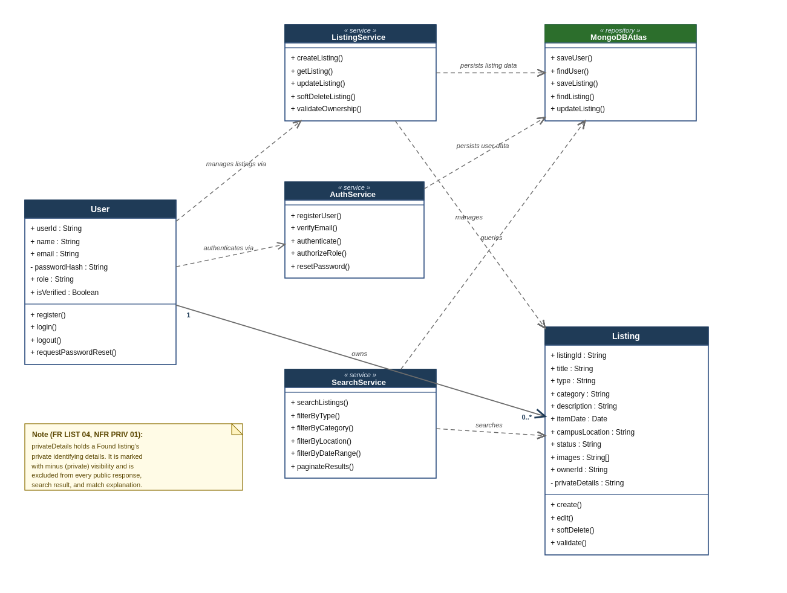
Figure 1. Class diagram for Phase 1, showing the User and Listing entities, the Auth, Listing, and Search services, the MongoDB Atlas data access layer, and the private fields required by FR LIST 04 and NFR PRIV 01.

3. Sequence Diagram
The sequence diagram below traces a verified user signing in and then creating a new listing, showing the message exchange between the React web client, the AuthService and ListingService modules of the Express API, and MongoDB Atlas. An alt combined fragment models the two outcomes of field validation: the valid data branch saves the listing and confirms success, and the invalid data branch returns a validation error instead, matching the Display Validation Error use case shown in Figure 3.
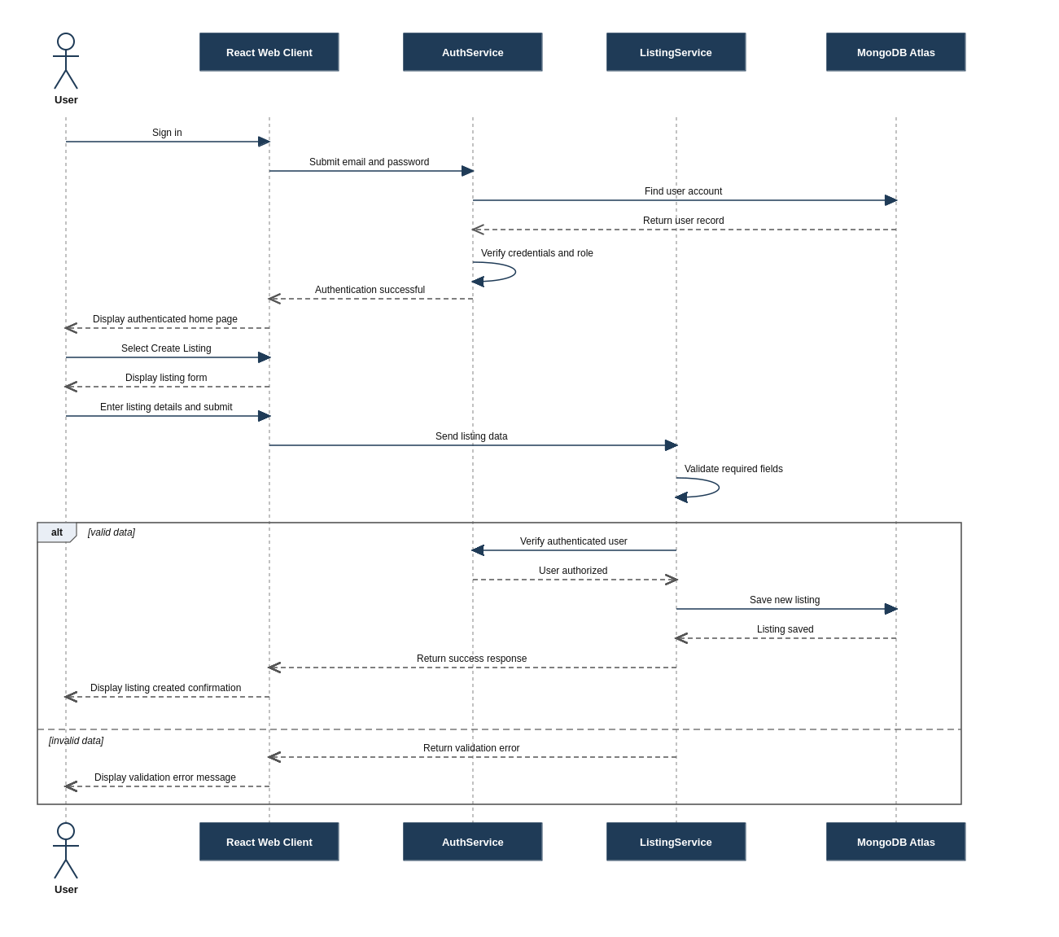
Figure 2. Sequence diagram for the Phase 1 sign in and create listing workflow, with an alt fragment covering the valid data and invalid data branches.

4. Use Case Diagram
The use case diagram below shows how Visitors and Registered Users interact with the Lost and Found system in Phase 1. A Registered User is modeled as a specialization of Visitor, so a Registered User can also browse, search, and filter listings in addition to managing their own listings and requesting a password reset, which closes a gap against FR AUTH 02 found during review.
Normal case: an authenticated user provides valid listing details, and the Create Listing use case includes Validate Listing Data and Verify Authentication before the listing is created successfully.
Error case 1, invalid data: the Display Validation Error use case extends Create Listing whenever submitted listing information is missing or incorrect, so the action is stopped instead of completing.
Error case 2, unauthorized action: the Reject Unauthorized Action use case extends Edit Own Listing and Soft Delete Own Listing whenever a user who is not the owner attempts to modify a listing, protecting listing ownership as required by FR LIST 03.
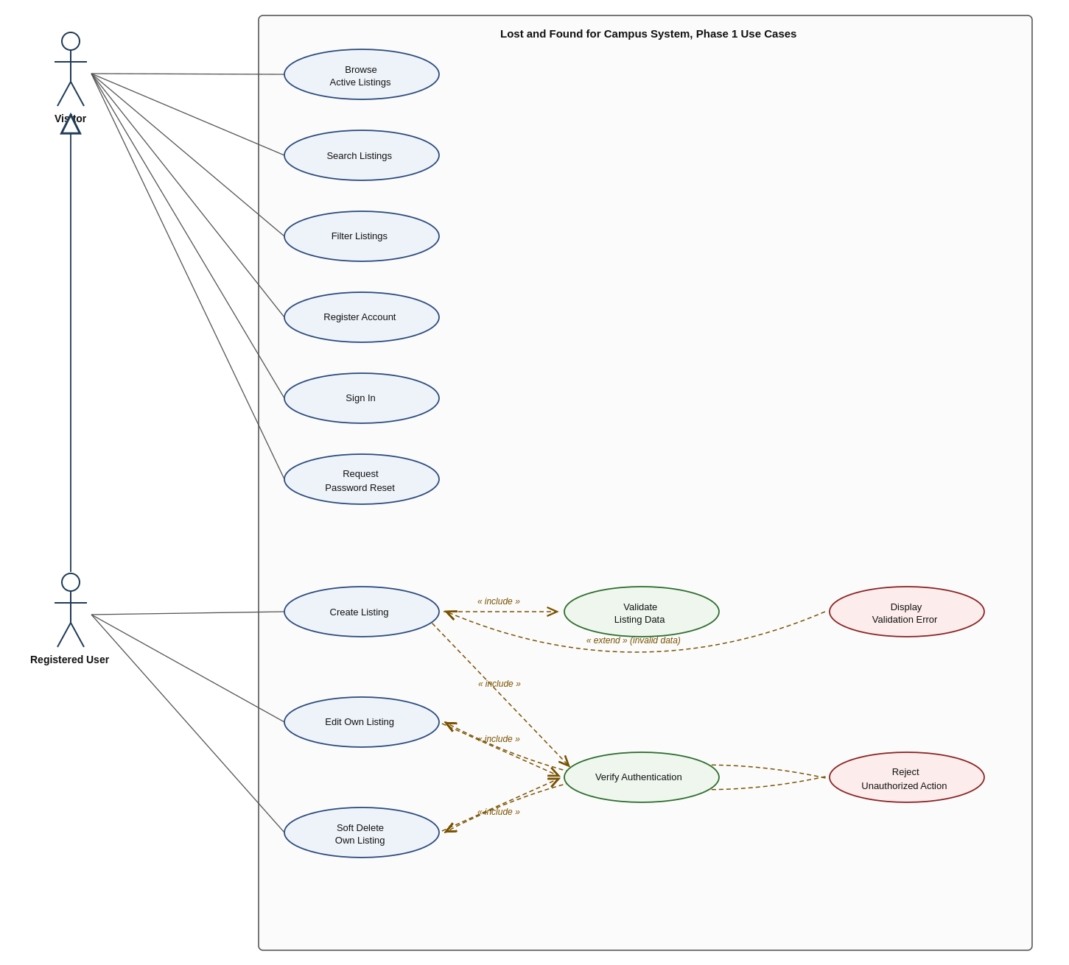
Figure 3. Use case diagram for Phase 1, showing the Visitor and Registered User roles, the Request Password Reset use case required by FR AUTH 02, the normal Create Listing flow, and the invalid data and unauthorized error flows.

